

**Tuesday, November 15, 2016**

Reading: read for 10 minutes

Math: shape packet due Fri.

Spelling: study words

*disguise a turkey due Thursday

**Monday, November 14, 2016**

Reading: Read for 10 minutes

Math: shape packet due Fri.

Spelling: study words

*disguise a turkey due Thursday

WEEKLY HOME PRACTICE SHEET: 11/14 – 11/17

**Thursday, November 17, 2016**

Reading: read for 10 minutes

Math: shape packet due Fri.

Spelling: practice test – test tomorrow!!

**Wednesday, Nov. 16, 2016**

Reading: read for 10 minutes

Math: shape packet due Fri.

Spelling: study words

*disguise a turkey due Thursday

**Spelling Words:**

us

bus

must

cut

cub

club

with

then

don’t

says

Challenge Words

jump

Thanksgiving

**Robust Words:**   
claimed

dine

groaned

classify

function

nutritious

**High Frequency Words:**

be

does

food

grow

live

many

This sheet should remain in your child’s take home folder. I will check to make sure it is signed each day. If there is a reason why your child has not completed their work, please write a note on that day. Thank you!

**SPECIAL SCHEDULE:**

Monday – Music

Tuesday – Art

Wednesday – Gym

Thursday – Gym

Friday – Library

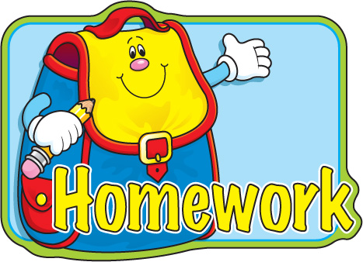

**Special Notes: Projects Due…….**

Disguise a Turkey is due Thursday. I can’t wait to see what you have come up with! This is what 50 looks like is due Friday. Feel free to hand anything in early!

Please sign

Please sign

Please sign

Please sign